IT24103333

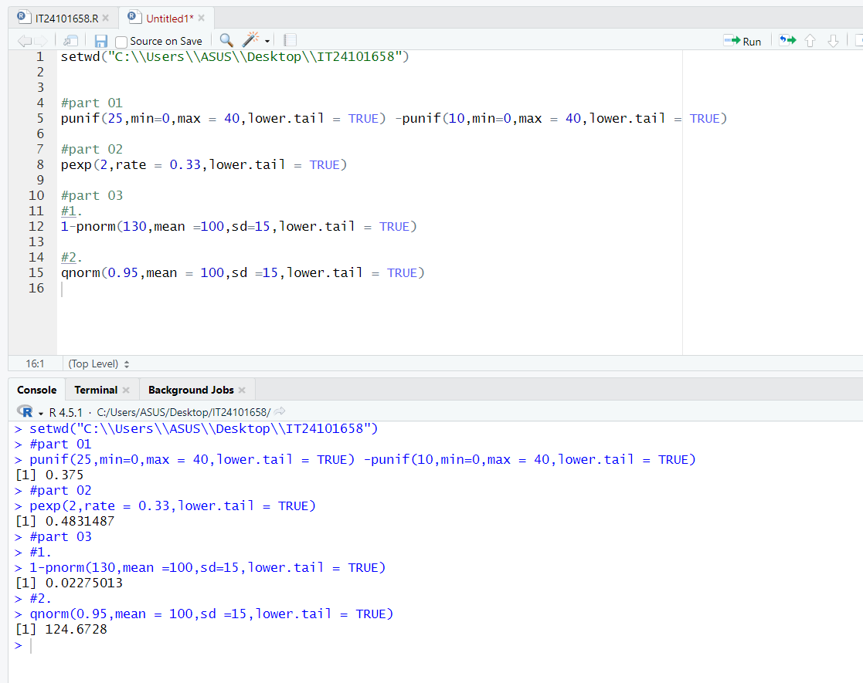Bandara K.M.D.S.